DEALS TO COCOA BEACH

If you’re ready to hit the surf or relax with family and friends on the pristine sands of Cocoa Beach, start planning with Virgin America now. Cocoa Beach is the quintessential Florida beach town. Book a trip to Cocoa Beach via Orlando International Airport on Virgin America. Live it up at 35,000 feet with WiFi, on-demand entertainment, and more on every flight.

(MARKET IMAGE HERE)

Find Deals From These Cities

INSERT FARE GRID FROM / TO Version (if available!)



Top Things To Do in Cocoa Beach

Whether you’re in for some adventure or a leisurely getaway, Cocoa Beach attractions appeal to everyone. While you’ll always be able to find something fun and exciting to do, below are a few suggested Cocoa Beach activities to get you off to a good start.

* Be adventurous and try some watersports. At 321 Kiteboarding and Watersports, you can take kitesurfing or surfing lessons, stand-up paddleboard tours, or rent kayaks, paddleboards, or kitesurfing gear. Whichever you choose, you’ll have a blast and want to go back for more.
* Explore the Cocoa Beach Pier. This boardwalk offers a lovely view of the beach and is full of shops, restaurants and boutiques. It’s also a perfect spot for some casual people watching.
* Visit Lori Wilson Park for the perfect little getaway. The clean, expansive beach at this park has gorgeous golden-hued sand that calls out for you to slow down and relax. Be sure to wander the nature trail while you’re there.

Travel Tips and Resources

[Must-Dos in Cocoa Beach](http://legendarycocoabeach.com/category/things-to-do)

[Cocoa Beach Hotels](http://www.tripadvisor.com/Hotels-g34145-Cocoa_Beach_Brevard_County_Florida-Hotels.html)

[Cocoa Beach Restaurants](http://www.tripadvisor.com/Restaurants-g34145-Cocoa_Beach_Brevard_County_Florida.html)

[Cocoa Beach Shopping Guide](http://legendarycocoabeach.com/shopping)

[Cocoa Beach Nightlife and Entertainment](http://legendarycocoabeach.com/dining-nightlife)

[Cocoa Beach Travel Tips](http://www.visitcocoabeach.com)

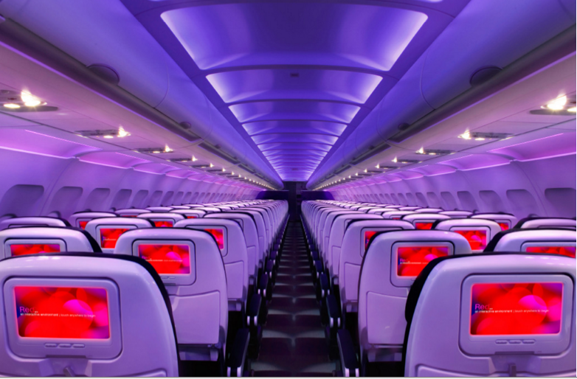

Main Cabin Main Cabin Select First Class

(add links to Cabin Class Pages)

Ready. Set. Fly.

Book your Mood-lit Ride to Cocoa Beach.

Fly into Orlando International Airport with Virgin America, and rent a car for the hour drive to Cocoa Beach. When you fly with us, you’ll enjoy refined amenities such as mood-lit cabins, custom-designed leather seats, and inflight WiFi. You’ll find everything you need to make you feel right at home on our flights.

Take a Virtual Tour

Add Terms & Conditions